**1.** What is the output of the following code?

1 cross_val_predict (lr2e, x_data, y_data, cv=3)

* The predicted values of the test data using cross-validation
* The average R^2 on the test data for each of the two folds
* This function finds the free parameter alpha

**2.** What dictionary value would we use to perform a grid search for the following values of alpha? 1,10, 100. No other parameter values should be tested

1 alpha=[1,10,100]

1 [{'alpha': [1,10,100]}]

1 [{'alpha': [0.001,0.1,1, 10, 100, 1000,10000,100000,100000],'normalize':[True,False]} ]

**3.** You have a linear model; the average R^2 value on your training data is 0.5, you perform a 100th order polynomial transform on your data then use these values to train another model. After this step, your average R^2 is 0.99; which of the following comments is correct?

* You should always use the simplest model
* The results on your training data is not the best indicator of how your model performs; you should use your test data to get a better idea
* 100-th order polynomial will work better on unseen data

**4.** Consider the following diagram of 4 fold cross-validation. From the diagram how many folds are used for training?

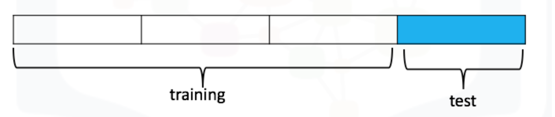

* 3
* 4
* 1

**5.** The following is an example of what?

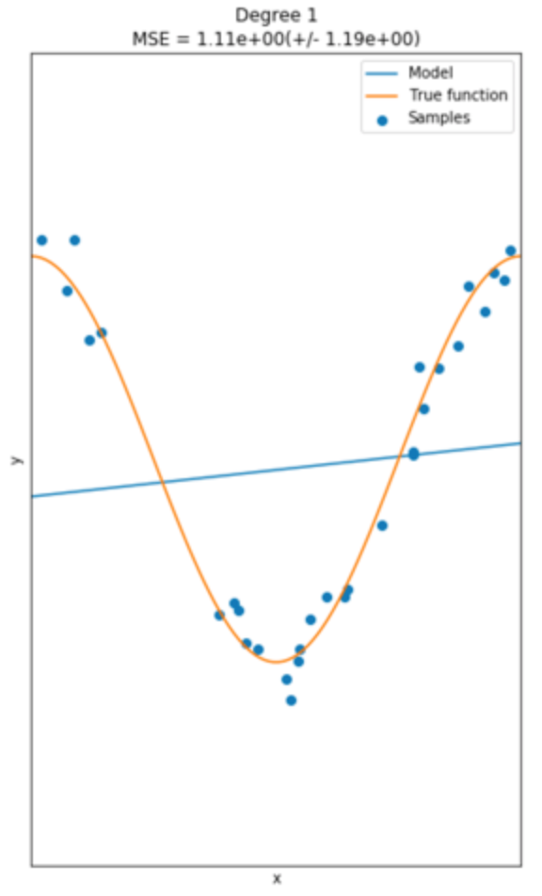

* Overfitting
* Perfect fit
* Underfitting